**CA3001 – Programming and Data Structures using C**

**Assignment 10 ­ - 02.02.2021**

**Q1**. Enter the marks of 5 students in Chemistry, Mathematics and Physics (each out of 100) using a structure named Marks having elements roll no., name, chem_marks, maths_marks and phy_marks and then display the percentage of each student.

Ans – C Program & Output:

#include <stdio.h>

struct Marks {

int roll_no;

char name[30];

float chem_marks, maths_marks, phy_marks;

};

int main() {

struct Marks marks[5];

for(int i=0; i<4; i++){

printf("Student %d\n",i+1);

printf("Enter roll no. :\n");

scanf("%d", &marks[i].roll_no);

printf("Enter name :\n");

scanf("%s",marks[i].name);

printf("Enter Chemistry marks :\n");

scanf("%f", &marks[i].chem_marks);

printf("Enter Maths marks :\n");

scanf("%f", &marks[i].maths_marks);

printf("Enter Physics marks :\n");

scanf("%f", &marks[i].phy_marks);

}

for(int i=0; i<4; i++) {

printf("Student %d\n",i+1);

float percentage = (marks[i].chem_marks + marks[i].maths_marks + marks[i].phy_marks)/300.0*100;

printf("Percentage : %f\n", percentage);

}

return 0;

}

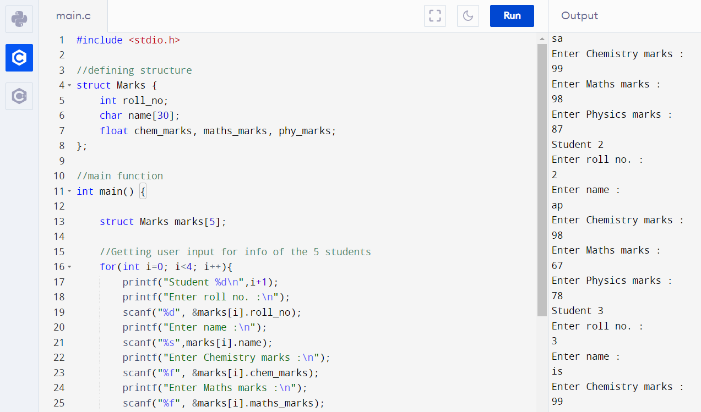

**Q3**. Write a structure to store the name, account number and balance of customers (more than 10) and store their information. - print the names of all the customers having balance less than $200. - add $100 in the balance of all the customers having more than $1000 in their balance and then print the incremented value of their balance.

Ans – C Program & Output:

#include<stdio.h>

void main()

{

struct bank

{

int acc_no;

char name[20];

int bal;

}b[5];

int i;

for(i=0;i<5;i++)

{

printf(" \n\n enter the acc_no,name,balance\n\n");

printf("\nenter the account no\n");

scanf("%d",&b[i].acc_no);

printf("\n enter the name\n");

scanf("%s",b[i].name);

printf("\n enter the balance\n");

scanf("%d",&b[i].bal);

}

for(i=0;i<5;i++)

{

if(b[i].bal<200)

{

printf("\n\n The acc_no,name,balance below RS:-200\n\n");

printf("\n the account no:-%d\n",b[i].acc_no);

printf("\n the name:-%s\n",b[i].name);

printf("\n the balance:-%d\n",b[i].bal);

}

}

}

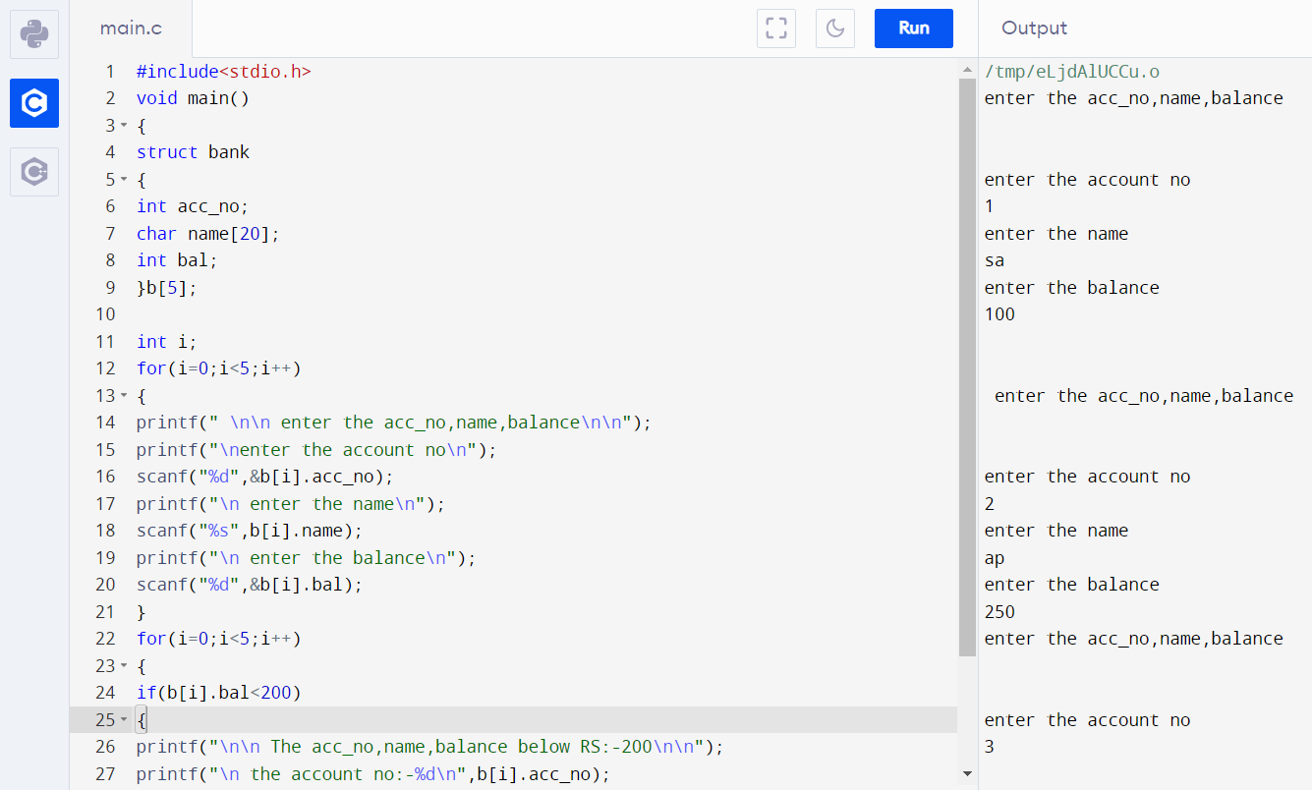

**Q5**. Let us work on the menu of a library. Create a structure containing book information like accession number, name of author, book title and flag to know whether book is issued or not. Create a menu in which the following can be done.

1 - Display book information

2 - Add a new book

3 - Display all the books in the library of a particular author

4 - Display the number of books of a particular title

5 - Display the total number of books in the library

6 - Issue a book

(If we issue a book, then its number gets decreased by 1 and if we add a book, its

number gets increased by 1)

Ans - C Program & Output:

#include<stdio.h>

#include<string.h>

void add();

void display();

void author();

void title();

void count();

void access();

struct book

{

int a; //a=accession number

char name[30],title[30],flag[6];

float price;

}b[100];

int d;

void main()

{

int i,n,c;

printf("Enter number of book\n");

scanf("%d",&n);

for(i=0;i<n;i++){

printf("Enter information of book no. %d\n",i+1);

printf("Accession number ");

scanf("%d",&b[i].a);

printf(" Name of author ");

scanf("%s",b[i].name);

printf("Title of book ");

scanf("%s",b[i].title);

printf("Price ");

scanf("%f",&b[i].price);

printf("Issue status yes/no: ");

scanf("%s",b[i].flag);

}

d=i;

printf("****menu*****");

printf("\n1. Add book information\n2. Display book information\n3. List all books of given author\n4. list the title of specified book\n5. List the count of books in the library\n6. List the books in the order of accession number\n 7.Exit\n");

printf("Choose an option\n");

scanf("%d",&c);

while(c!=7){

if(c==1)

add();

if(c==2)

display();

if(c==3) author();

if(c==4) title();

if(c==5) count();

if(c==6) access();

if(c!=1 && c!=2 && c!=3 && c!=4 && c!=5 && c!=6)

printf("Invalid Input\nPlease enter valid input\n");

printf("1. Add book information\n2. Display book information\n3. List all books of given author\n4. list the title of specified book\n5. List the count of books in the library\n6. List the books in the order of accession number\n 7.Exit\n");

printf("Choose an option\n");

scanf("%d",&c);

}

}

void add(){

int i,n;

printf("Enter number of book added\n");

scanf("%d",&n);

for(i=d;i<n+d;i++){

printf("Enter information of additional book no. %d\n",i-d+1);

printf("Accession number ");

scanf("%d",&b[i].a);

printf(" Name of author ");

scanf("%s",b[i].name);

printf("Title of book ");

scanf("%s",b[i].title);

printf("Price ");

scanf("%f",&b[i].price);

printf("Issue status yes/no: ");

scanf("%s",b[i].flag);

}

d=d+n;

}

void display(){

printf("Accession number Name title price issue status\n");

for(int j=0;j<d;j++)

printf("%d %s %s %f %s\n",b[j].a,b[j].name,b[j].title,b[j].price,b[j].flag);

}

void author()

{

char A[30],j,c;

printf("Enter author name ");

scanf("%s",A);

printf("Accession number Name title price issue status\n");

for(int j=0;j<d;j++){

c=strcmp(A,b[j].name);

if(c==0)

printf("%d %s %s %f %s\n",b[j].a,b[j].name,b[j].title,b[j].price,b[j].flag);

}

}

void title()

{

char t[30];

int c,i,j;

printf("Enter Title of a book ");

scanf("%s",t);

for(i=0;i<d;i++)

{

c=strcmp(t,b[i].title);

if(c==0){

printf("Accession number Name title price issue status\n");

printf("%d %s %s %f %s\n",b[i].a,b[i].name,b[i].title,b[i].price,b[i].flag);

}

}

}

void count()

{

printf("no. of books in libarary is %d\n",d);

}

void access()

{

int i,j,E[100],c[100],a;

for(i=0;i<d;i++){

E[i]=b[i].a;

c[i]=i;

}

for(i=0;i<d;i++)

for(j=i;j<d;j++)

if(E[i]>E[j]){

a=E[i];

E[i]=E[j];

E[j]=a;

a=c[i];

c[i]=c[j];

c[j]=a;

}

printf("Accession number Name title price issue status\n");

for(j=0;j<d;j++)

printf("%d %s %s %f %s\n",b[c[j]].a,b[c[j]].name,b[c[j]].title,b[c[j]].price,b[c[j]].flag);

}

